The Very Hungry Caterpillar
Written by Eric Carle
Hello Parents and carers,
I hope that this letter finds you all safe and well. As we begin our 6th week of “home-schooling” I’m sure some of you would welcome some ideas and activities to busy and interest your children. I thought I could offer some useful, fun ideas and activities for you to try by choosing a key-story.
I have chosen ‘The Very Hungry Caterpillar’ by Eric Carle. This is a simple story that can be used to teach a number of subject skills to a range of ages and abilities. Please don’t worry if you don’t have a copy of the story at home, as I have copied some links below for you to share with your children. It would be lovely for the children to learn some of the story and join in using actions and signs. Please feel free to pick and choose from the suggested activities below, and do send us photos and videos- we’re all missing the children so much, and enjoy receiving photos of them continuing their learning journeys with you at home. Hope you have a wonderful week.
https://www.youtube.com/watch?v=75NQK-Sm1YY
https://www.youtube.com/watch?v=kQNxBrONqaA
Look at some of the words used in the story and discuss their meanings. Perhaps some of your children may already know the Makaton signs:
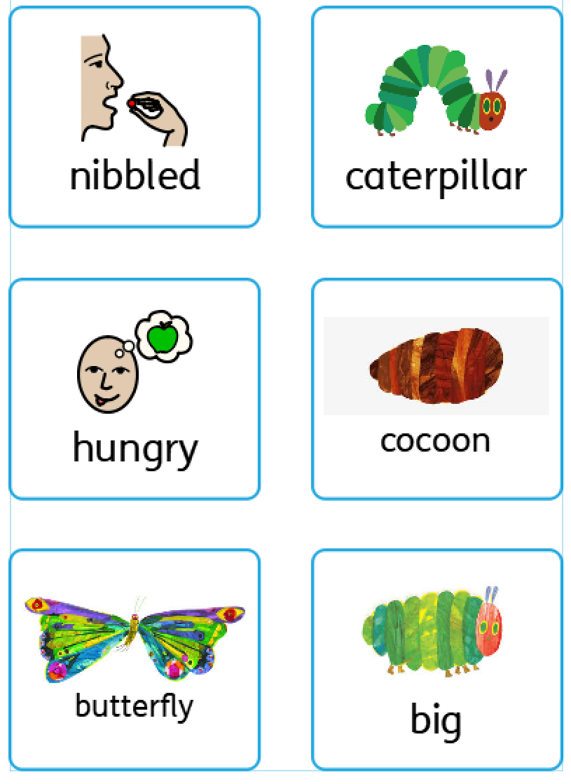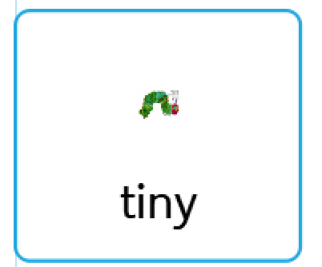

Patterns:
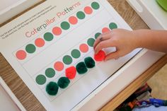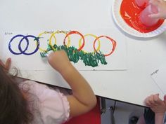
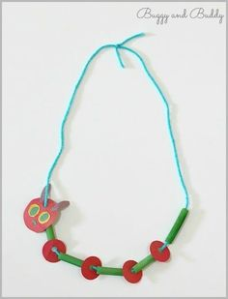
Number hunts, counting and days of the week:
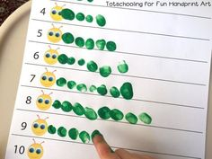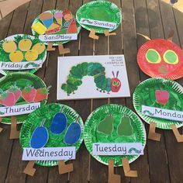
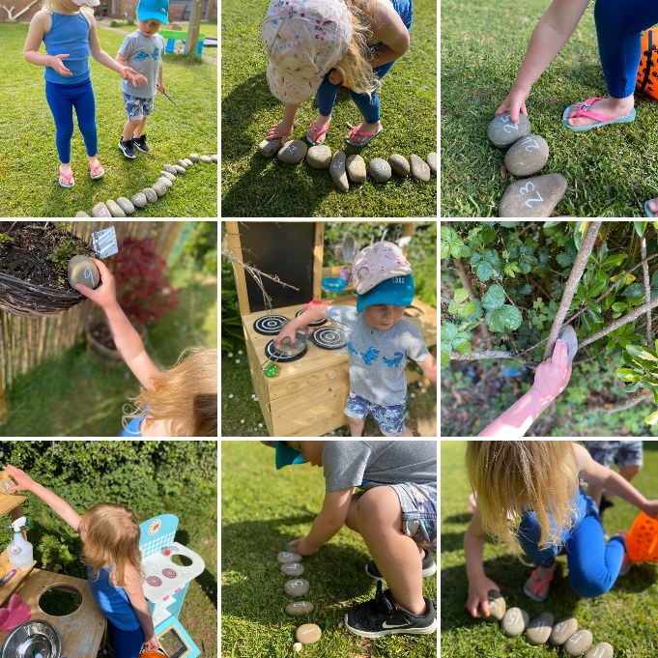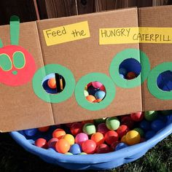

Sensory Storytelling, language and communication, fine motor skills:
